**Diabetes Dashboard Analysis For Business Growth And Decision-Making**

**1. Business Understanding:**

The dashboard appears to focus on diabetes-related health metrics. It likely helps healthcare professionals and researchers analyze factors influencing diabetes, such as glucose levels, insulin levels, pregnancies, age, blood pressure, and diabetes pedigree function.

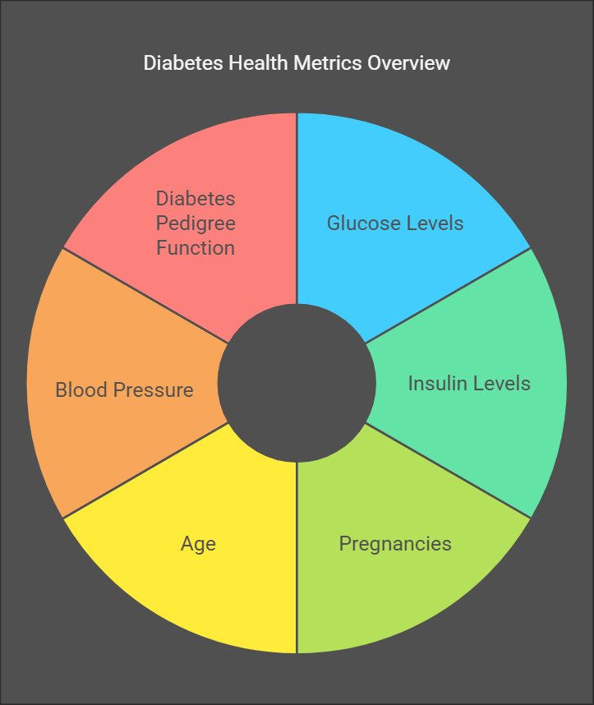

**2. Data Required:**

To analyze diabetes risk factors, the dataset includes:

* **Age** (years)
* **Pregnancies** (number of times pregnant)
* **Glucose** levels (mg/dL)
* **Insulin** levels (µU/mL)
* **Blood Pressure** (mmHg)
* **Diabetes Pedigree Function** (genetic likelihood of diabetes)
* **Outcome** (whether the person has diabetes or not)

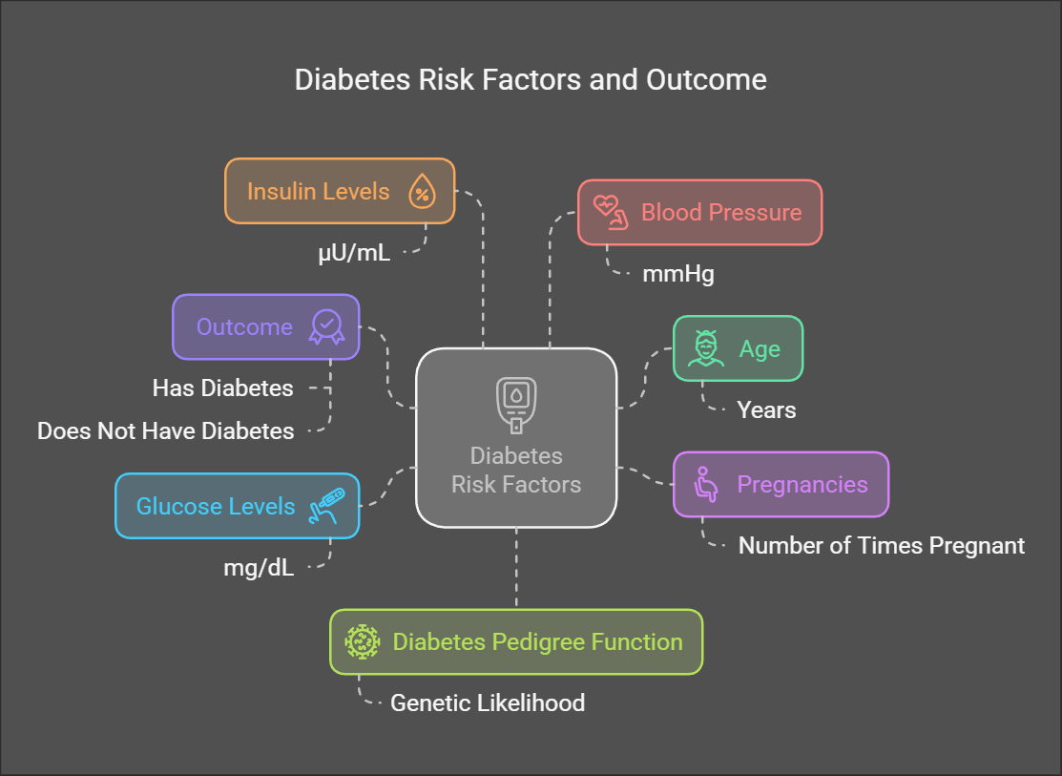

**3. Data Collection:**

The data is likely sourced from medical records, health surveys, or clinical research studies involving diabetes patients.

**4. Data Validation and Understanding:**

* The presence of missing or extreme values should be checked.
* Trends such as how glucose and insulin levels vary with age and diabetes status can be observed.
* Relationships between pregnancy and diabetes should be examined, as gestational diabetes is a known condition.

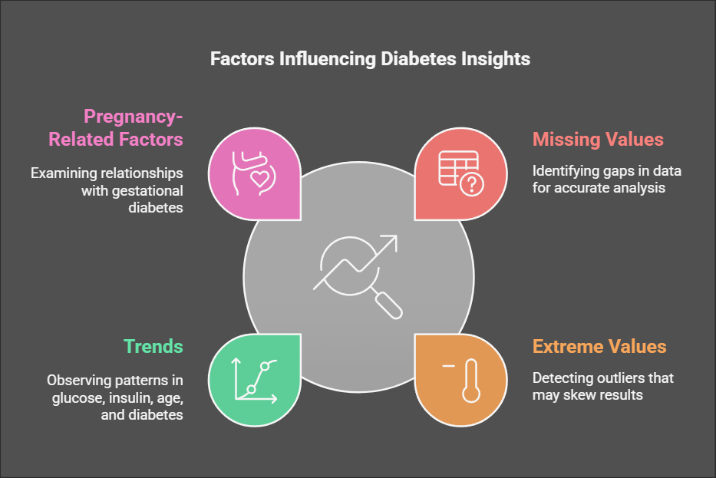

**5. Data Cleaning:**

* Handling missing values in glucose, insulin, or blood pressure.
* Removing outliers (e.g., insulin values exceeding normal physiological ranges).
* Normalizing data for better visualization and accuracy.

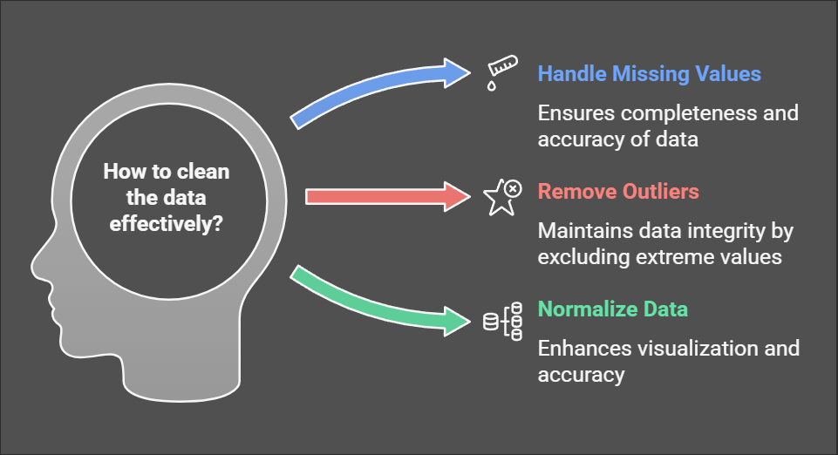

**6. Data Analysis Using Different Tools:**

The visualizations indicate:

* **Correlation Analysis**: Identifying relationships between variables.
* **Comparative Analysis**: Observing diabetes outcomes across different age groups, pregnancy counts, and insulin levels.
* **Trend Analysis**: Understanding how glucose and insulin levels change with other health factors.

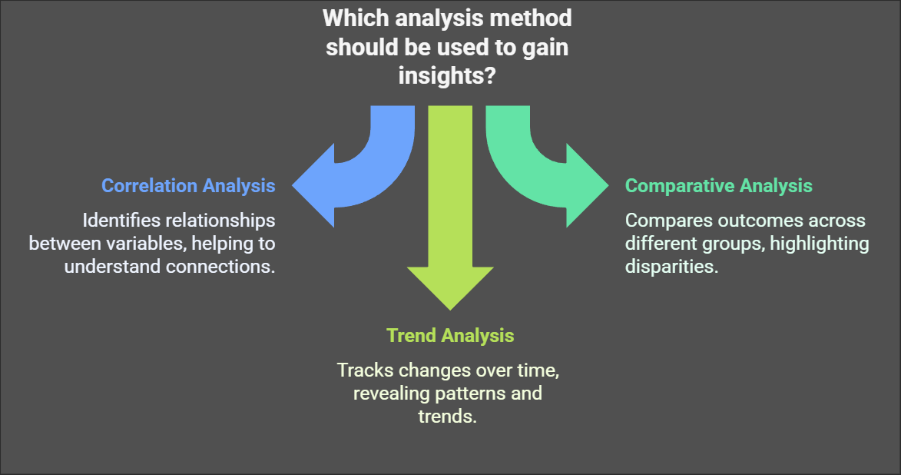

**7. Dashboard Preparation:**

The dashboard presents visual relationships through scatter plots and bar charts:

* **Age vs. Pregnancies**: Older individuals tend to have a higher number of pregnancies.
* **Age vs. Diabetes Pedigree Function**: Helps assess hereditary risks.
* **Pregnancies vs. Diabetes Outcome**: Higher pregnancy counts might be linked to diabetes risk.
* **Insulin vs. Glucose**: Identifying insulin resistance patterns.
* **Blood Pressure vs. Pregnancies**: Checking if pregnancy impacts blood pressure.
* **Pregnancies vs. Insulin**: Understanding insulin levels in pregnant women.

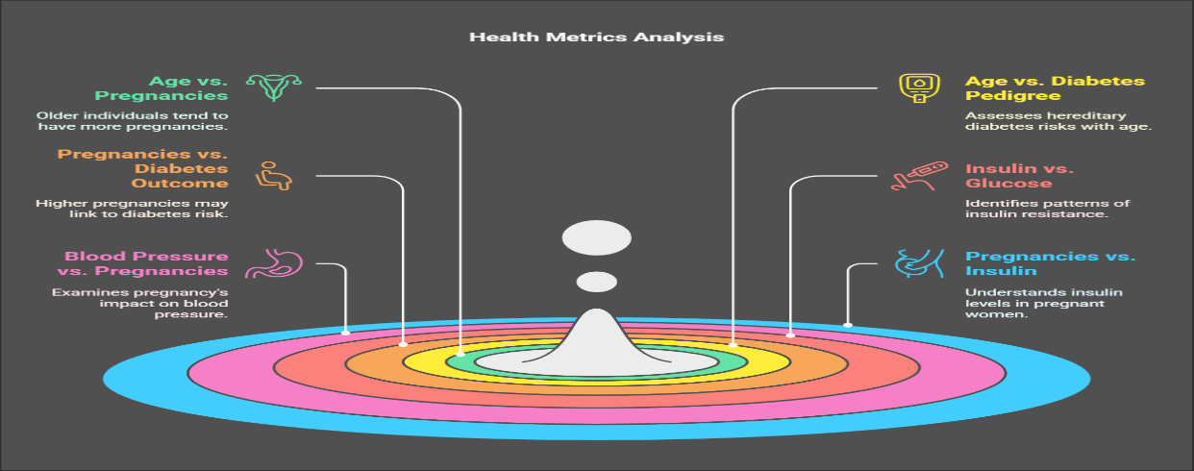

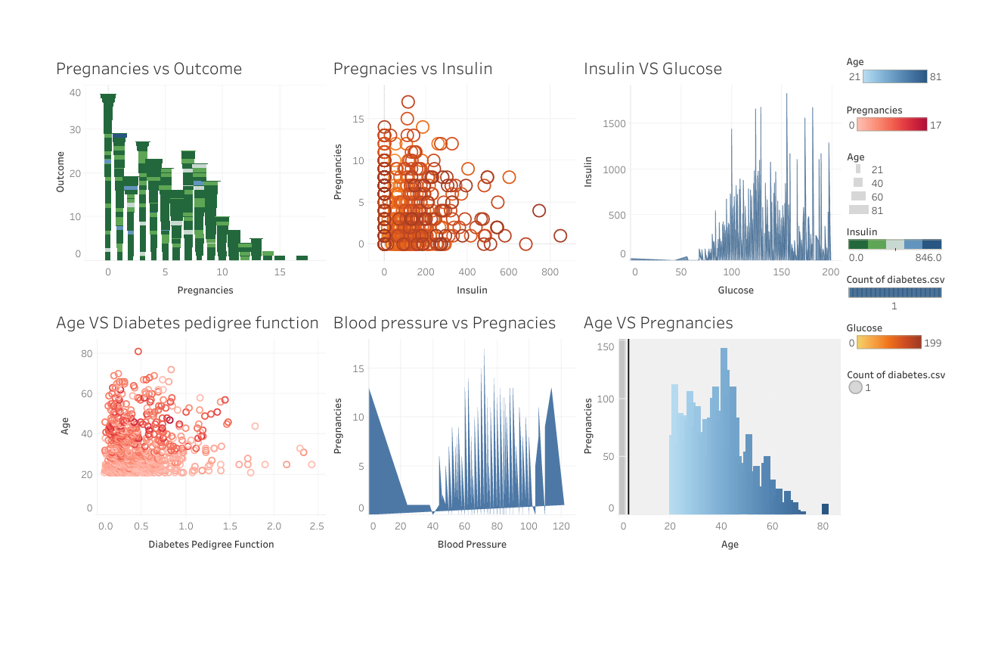

**8. Meaningful Information:**

* Higher glucose levels often correlate with increased insulin levels.
* More pregnancies may increase diabetes risk.
* Blood pressure and insulin resistance might be linked to diabetes development.
* Hereditary factors (Diabetes Pedigree Function) play a role in diabetes risk.

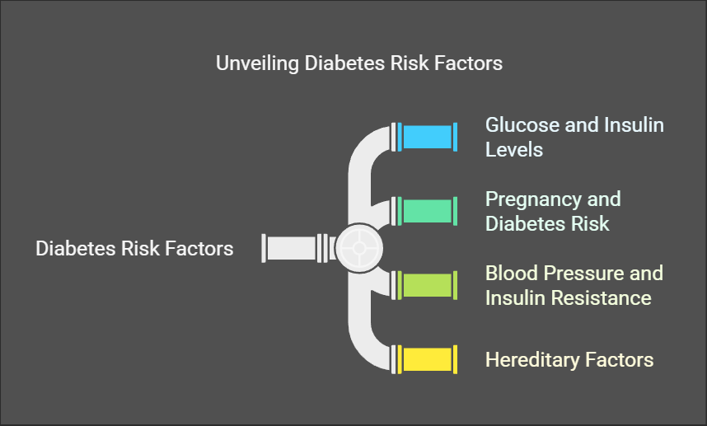

**9. Decision & Business Growth:**

* **For Healthcare Providers:** Early detection of diabetes through risk assessment can improve patient care.
* **For Researchers:** Insights into diabetes risk factors can help develop prevention strategies.
* **For Insurance Companies:** Data can be used for risk assessment in health insurance policies.
* **For Pharmaceutical Companies:** Targeted medication development for diabetes-prone individuals

